Set up instructions for ASRS

Step 1: Connect the channels to channels underneath at a right angle to elevate them. The smaller channels can be used as the feet while the larger channels should be used as guides. You should have one larger channel used as the guide and three smaller channels as feet. The motor bracket should be screwed in from the bottom of one of the side channels 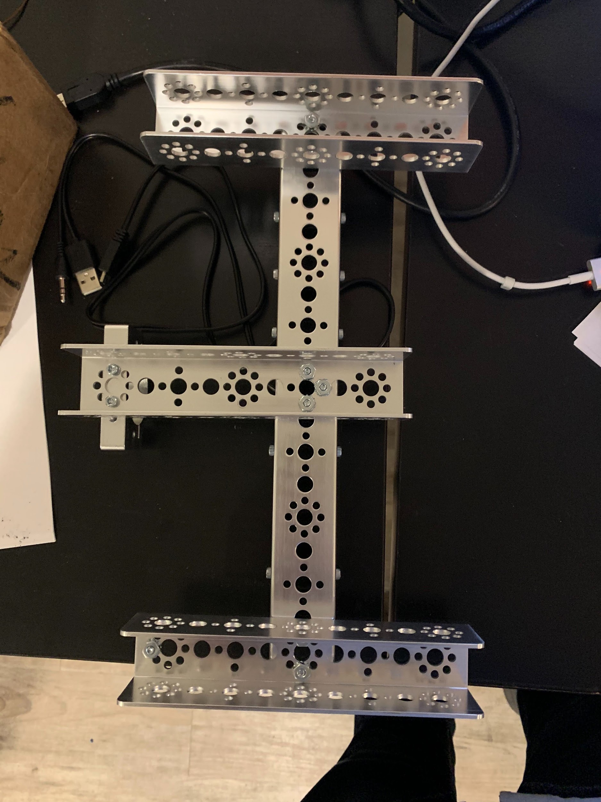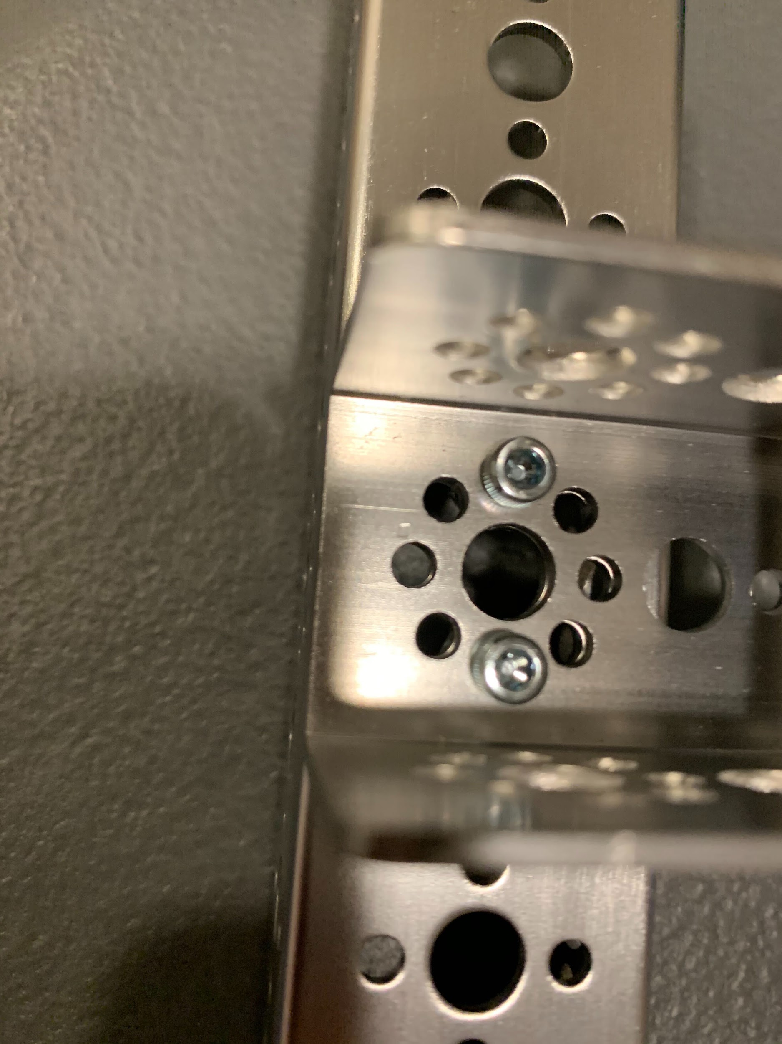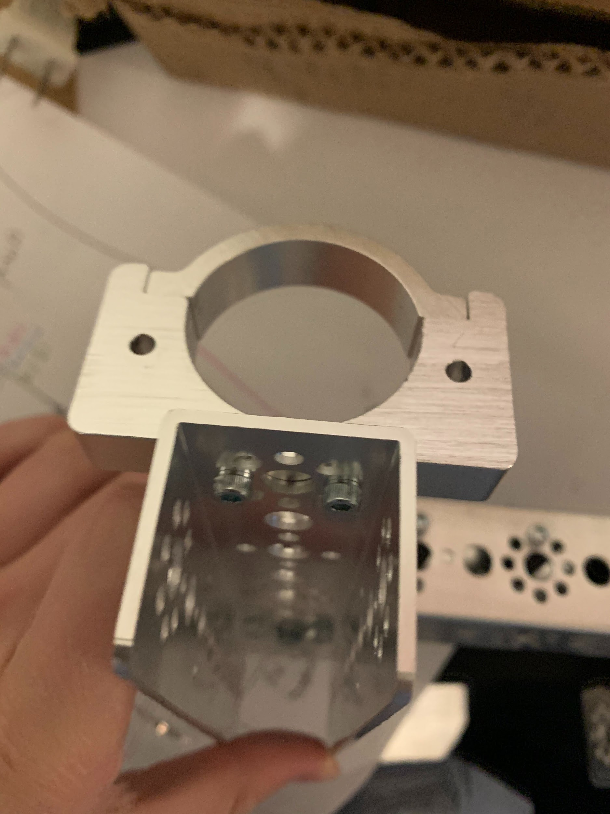

Step 2: place the sliders into the channels. Use the center of one of the channels as the origin and traveling outwards from there in both directions, place sliders. Bolt them into place but don’t fully tighten them. At this point, you can connect a second channel into place. Use the semi-circular flat plates to connect the channels and bolt the sliders into place through the flat plates. Continue adding the sliders and make sure to add another foot in place.

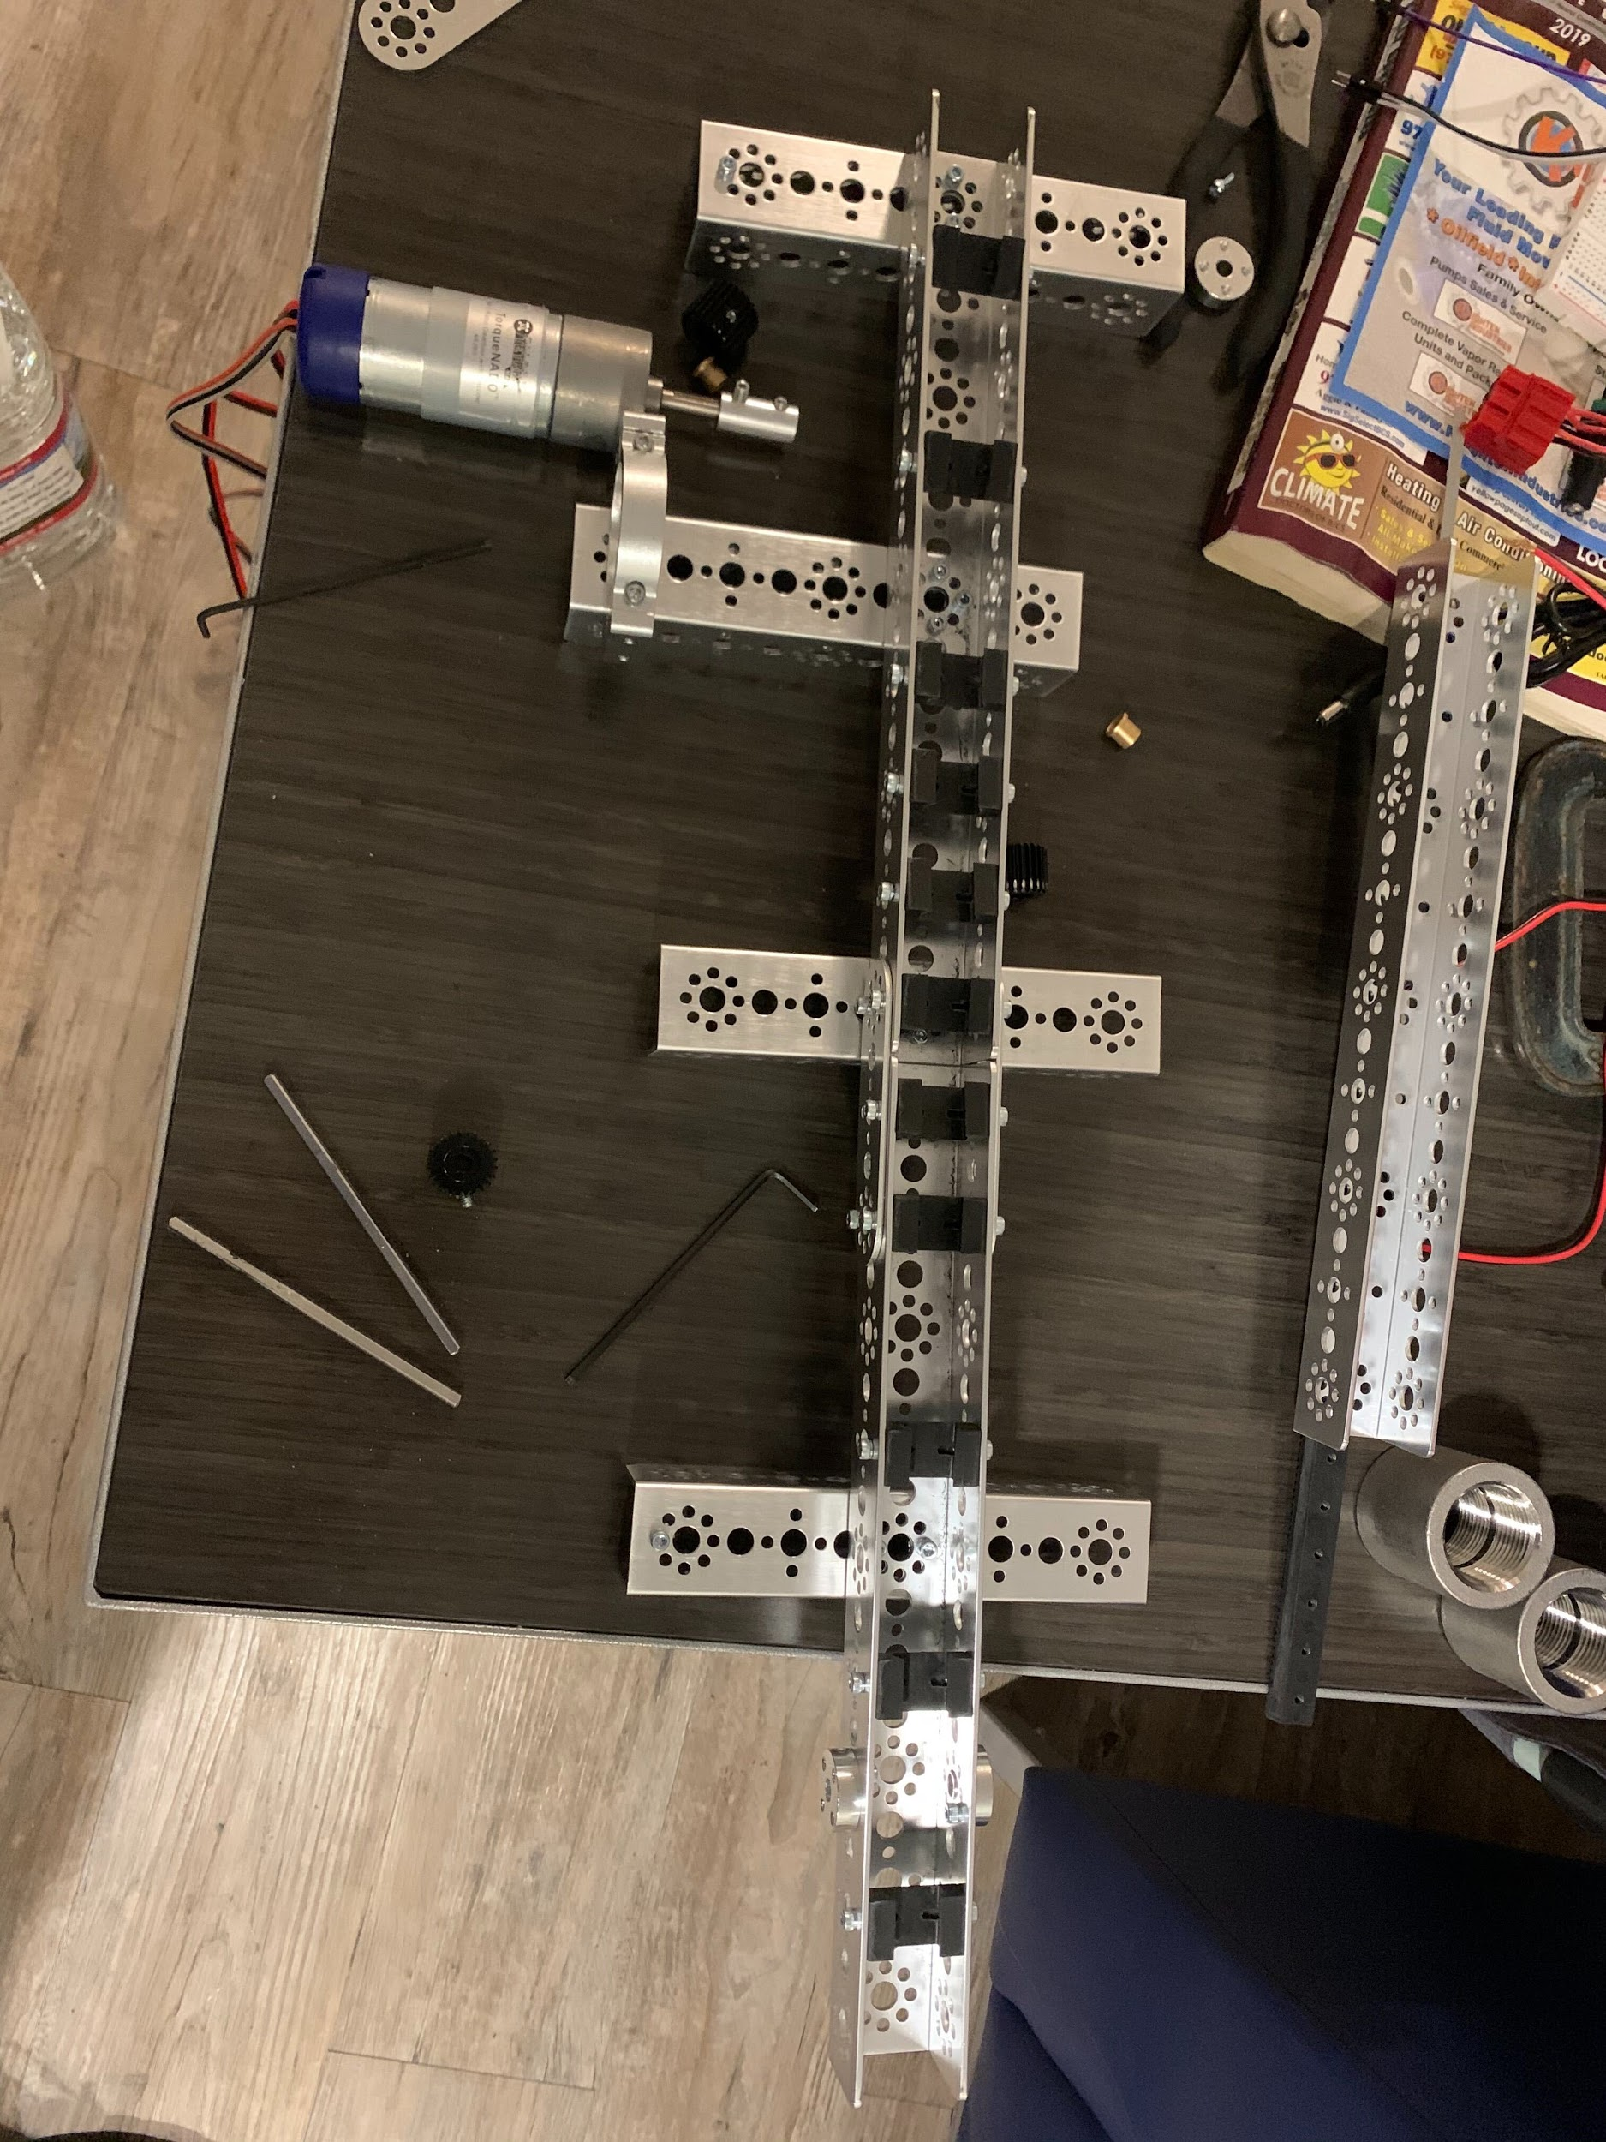

Step 3: connect the motor to the 4.7 mm shaft with the 6mm to 4.7 mm shaft coupler. Screw the set screws into place over the flat parts of each axle. Slide the axle through the bushing, through the center hole, and through the pinion gear. Tighten the set screw in the pinion gear down over the flat part of the axle. Once this is done, line the axle and motor up so the axle is sitting straight through the center of the hole and clamp the motor down and screw the bolts in.

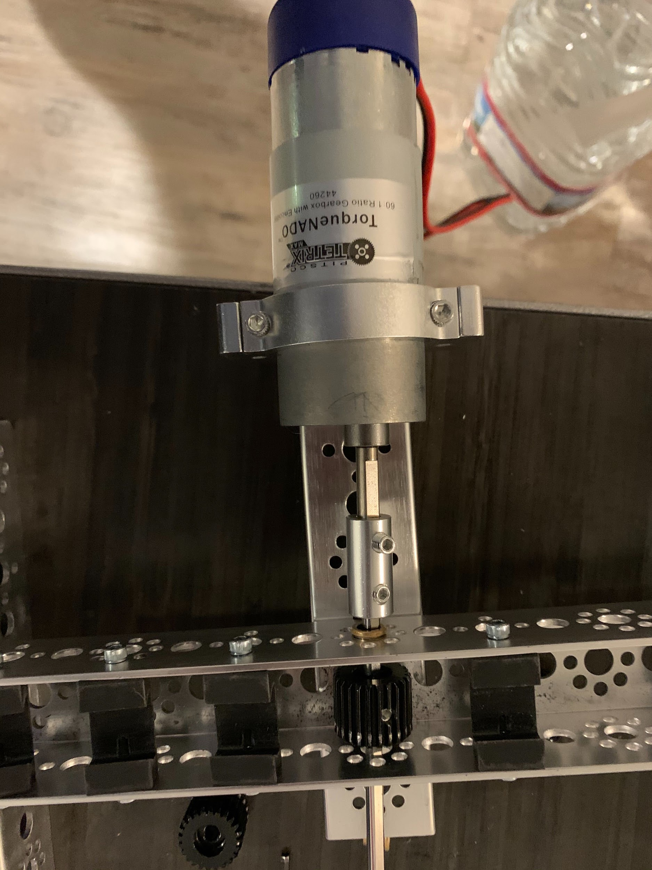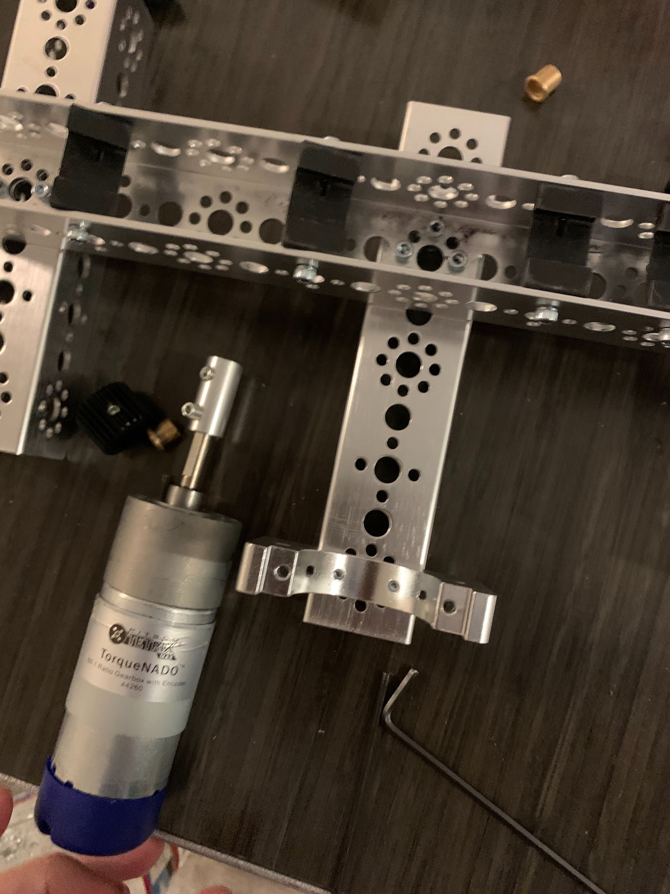

Step 4: Put together the channels and racks. Line up 6 288mm (the long ones) channels. Place the racks on the outer bottom of the channels in the center. Line the back of one of the racks up with one of the back edges. Using the holes inside the rack and the holes in the center of the channels, screw them in using the small screws provided. The racks are already threaded. Do not screw so far as to impede the teeth of the racks. Use at least two screws on every rack for every channel it touches. There should be 13 racks. When connecting the channels, the semi-circular flat plates should be used to connect them and the kep nuts. Use two screws per plate per channel. When the racks once again line up with the edge, use two semi-circular plates to continue.

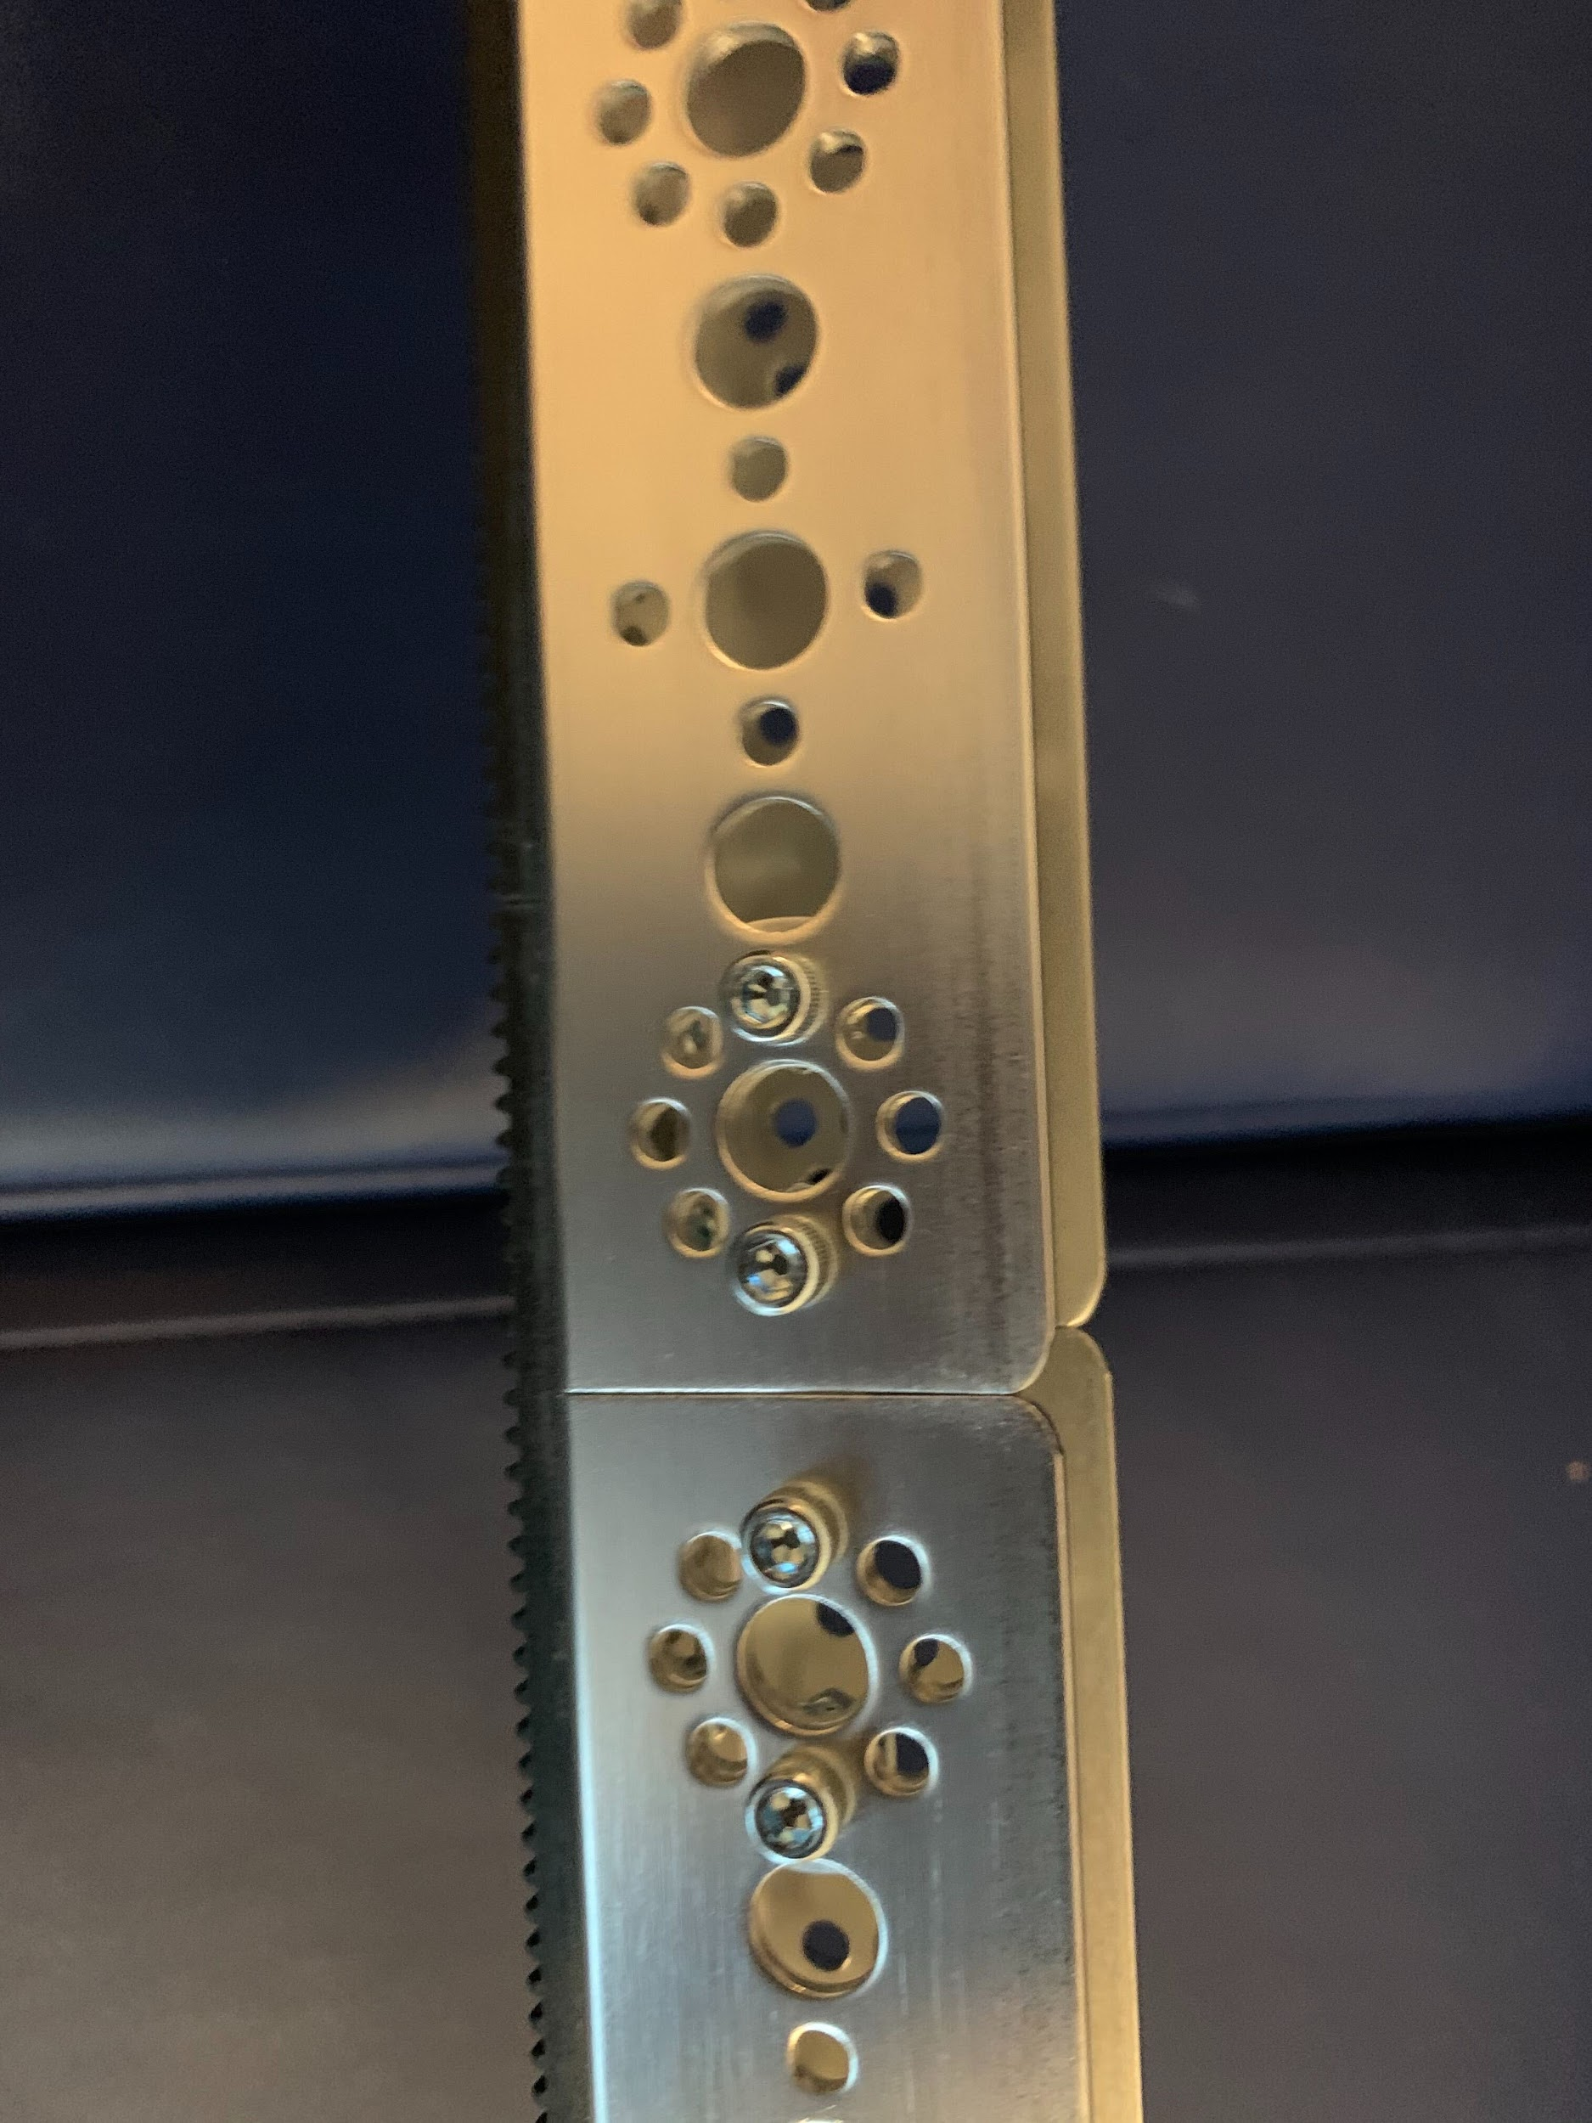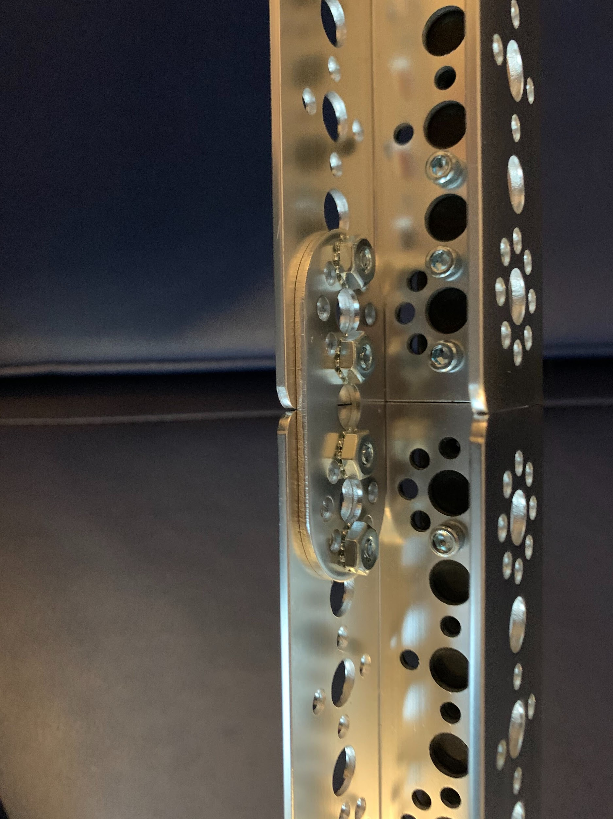

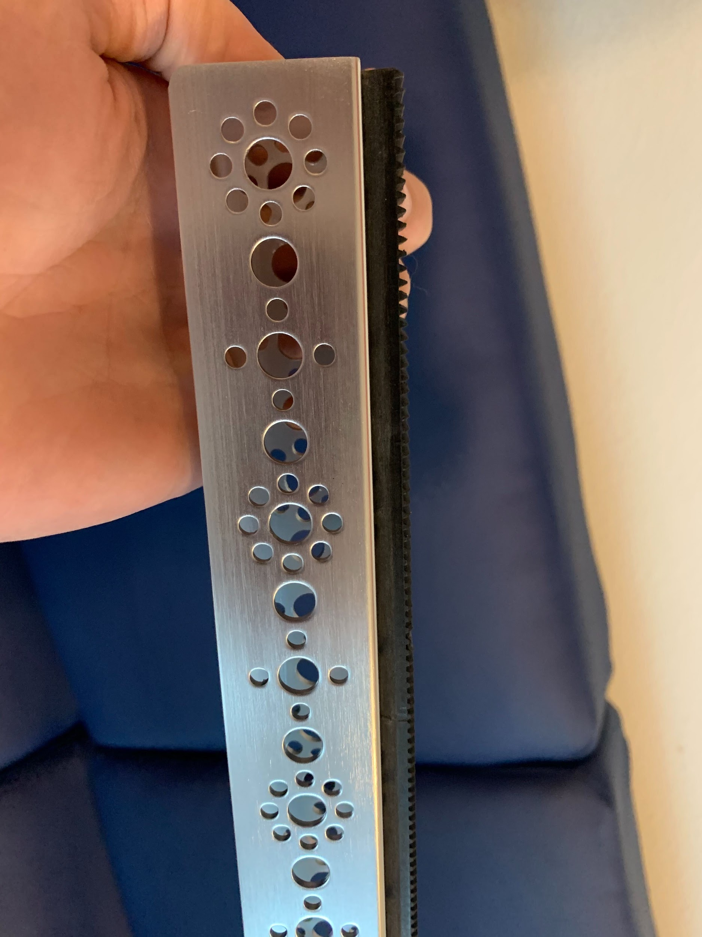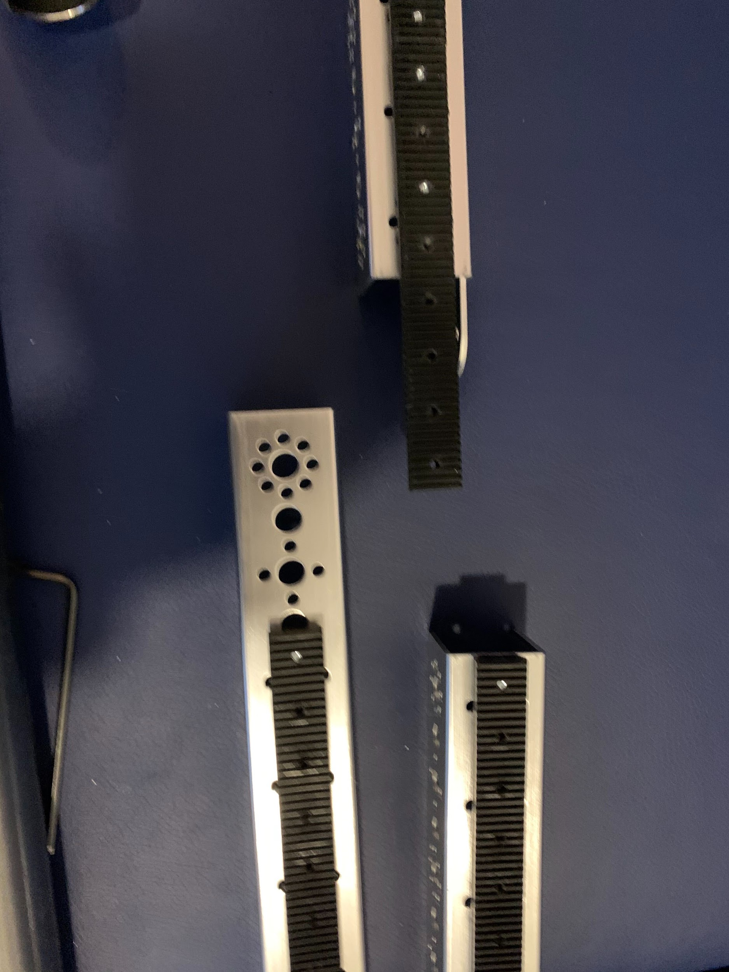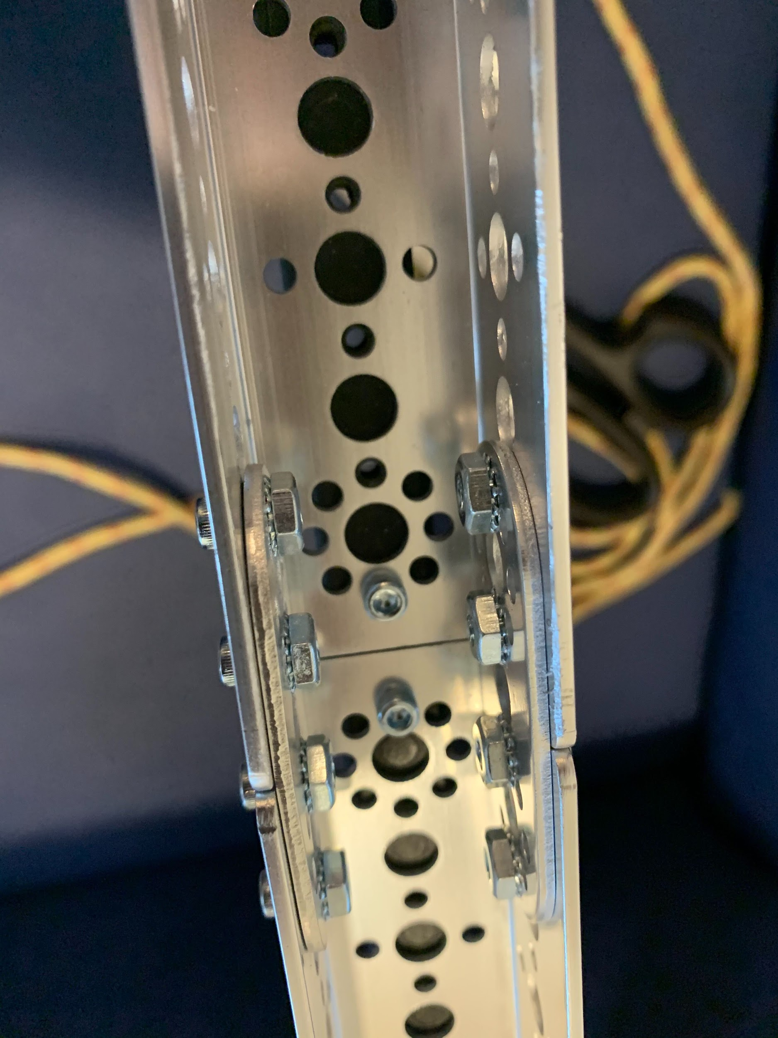

Step 5: Couple the 1” diameter pipe pieces together using the couplers. This should give you 8 feet of pipe.

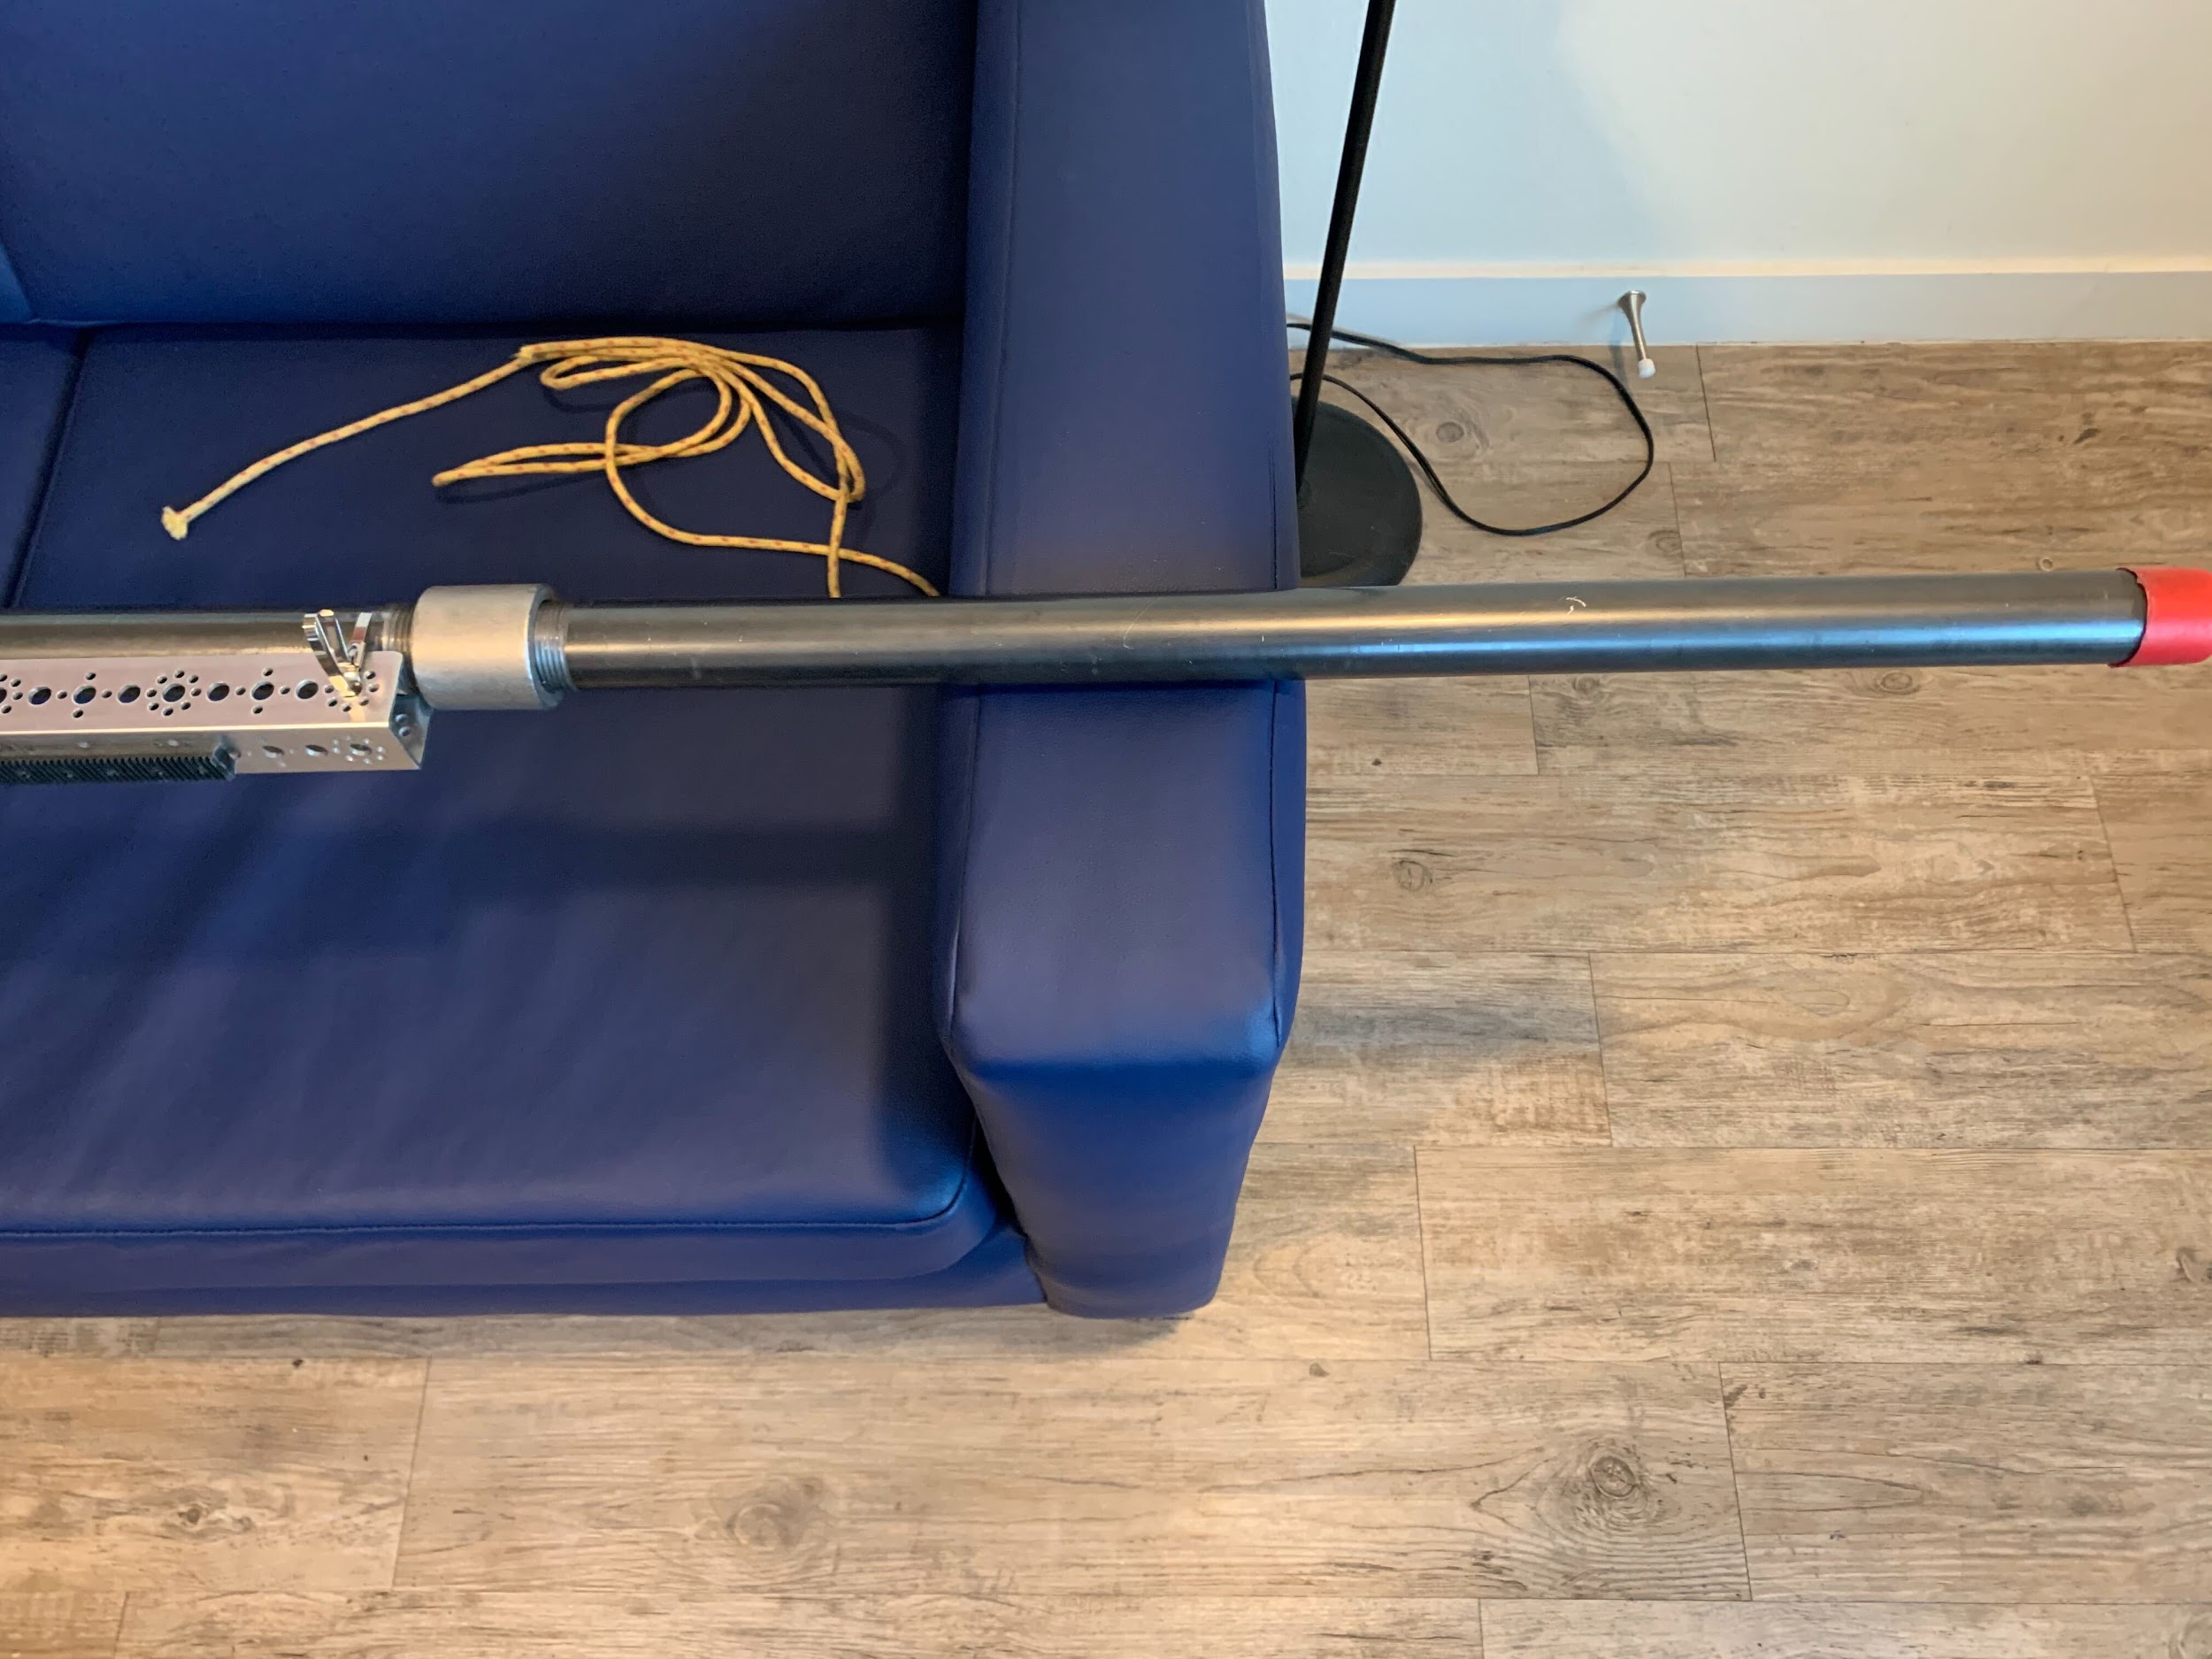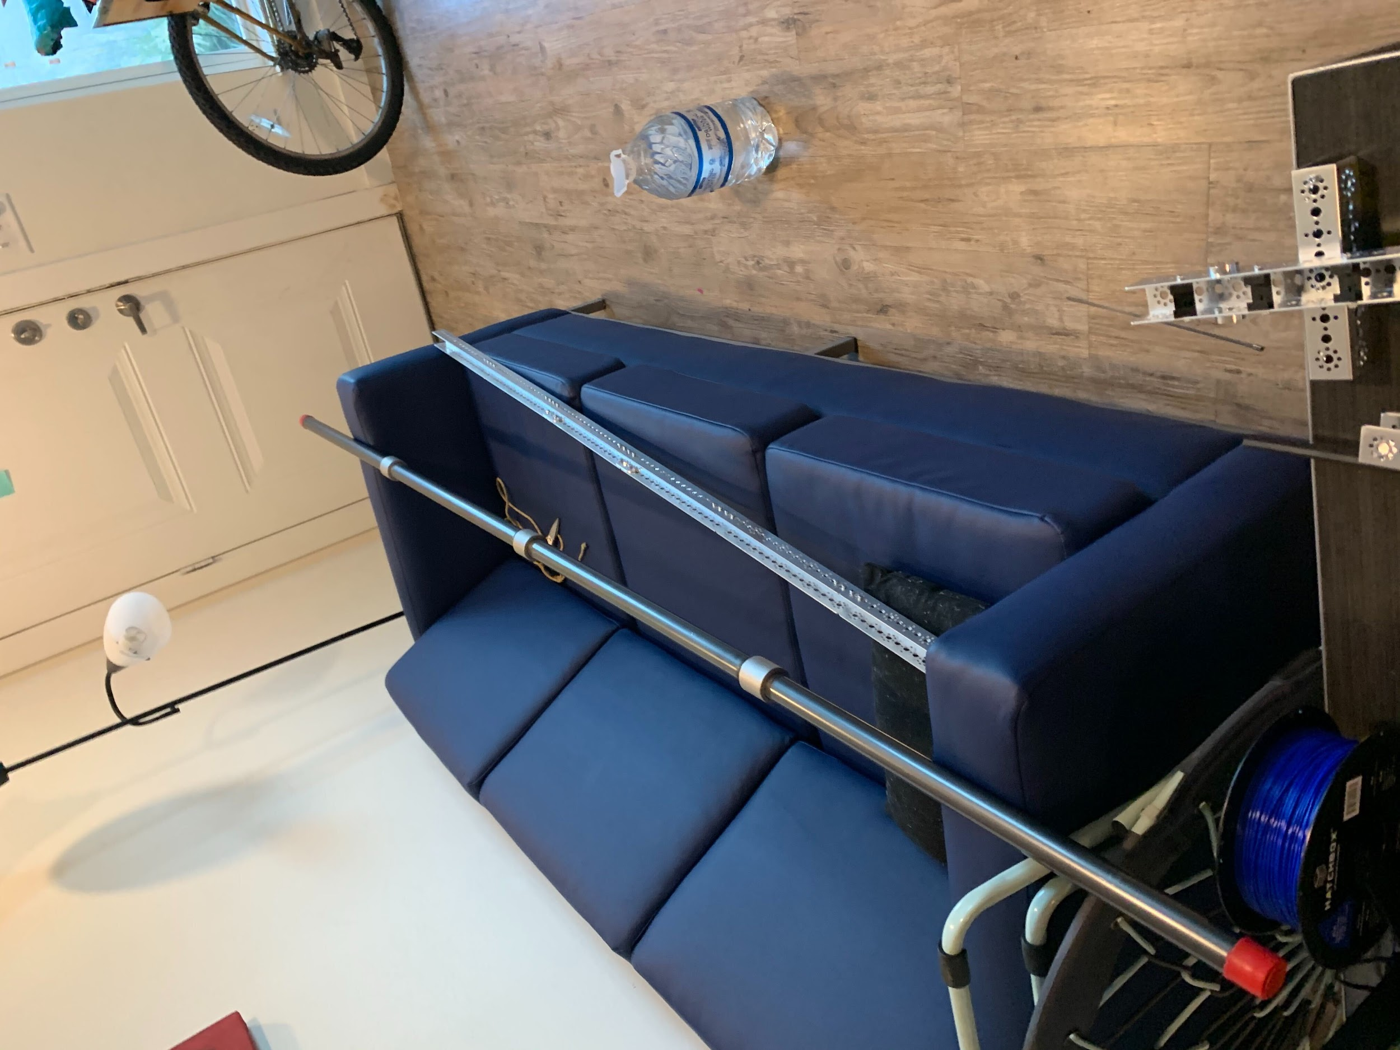

Step 6: Place and affix the 8ft pipe on the 6ft channel assembly. Use the metal zip ties to fast them down. Leave 2.5 feet of pipe extending past the edge of the channel. This is the leading edge.

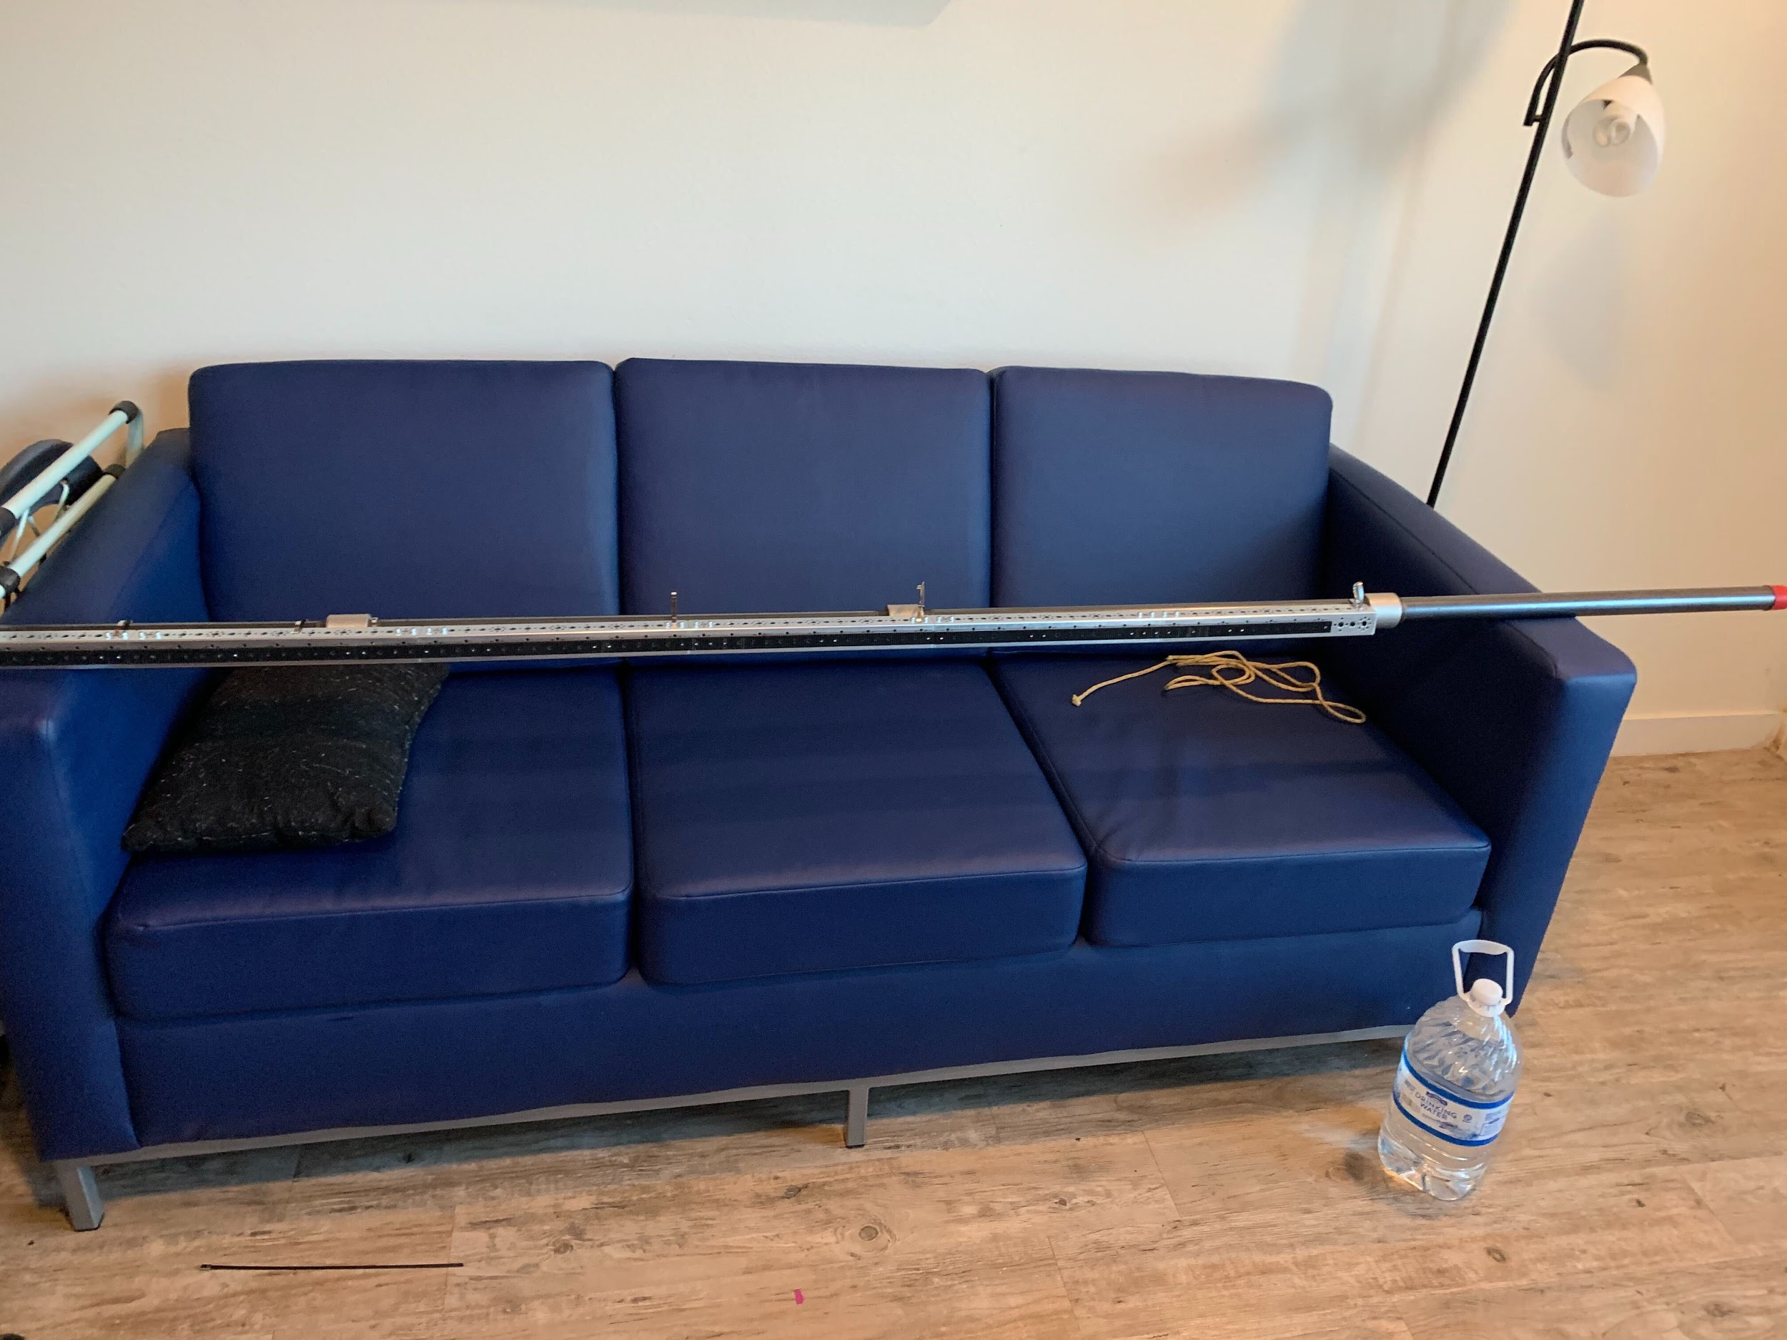

Step 7: Make sure bolts holding sliders in place are NOT TIGHT. Tighten them as far as they go, and then turn back by 90º. This makes the motion smoother and gets caught less. With a firm press, they should be able to rotate to the position in the picture. Make sure they are generally aligned.

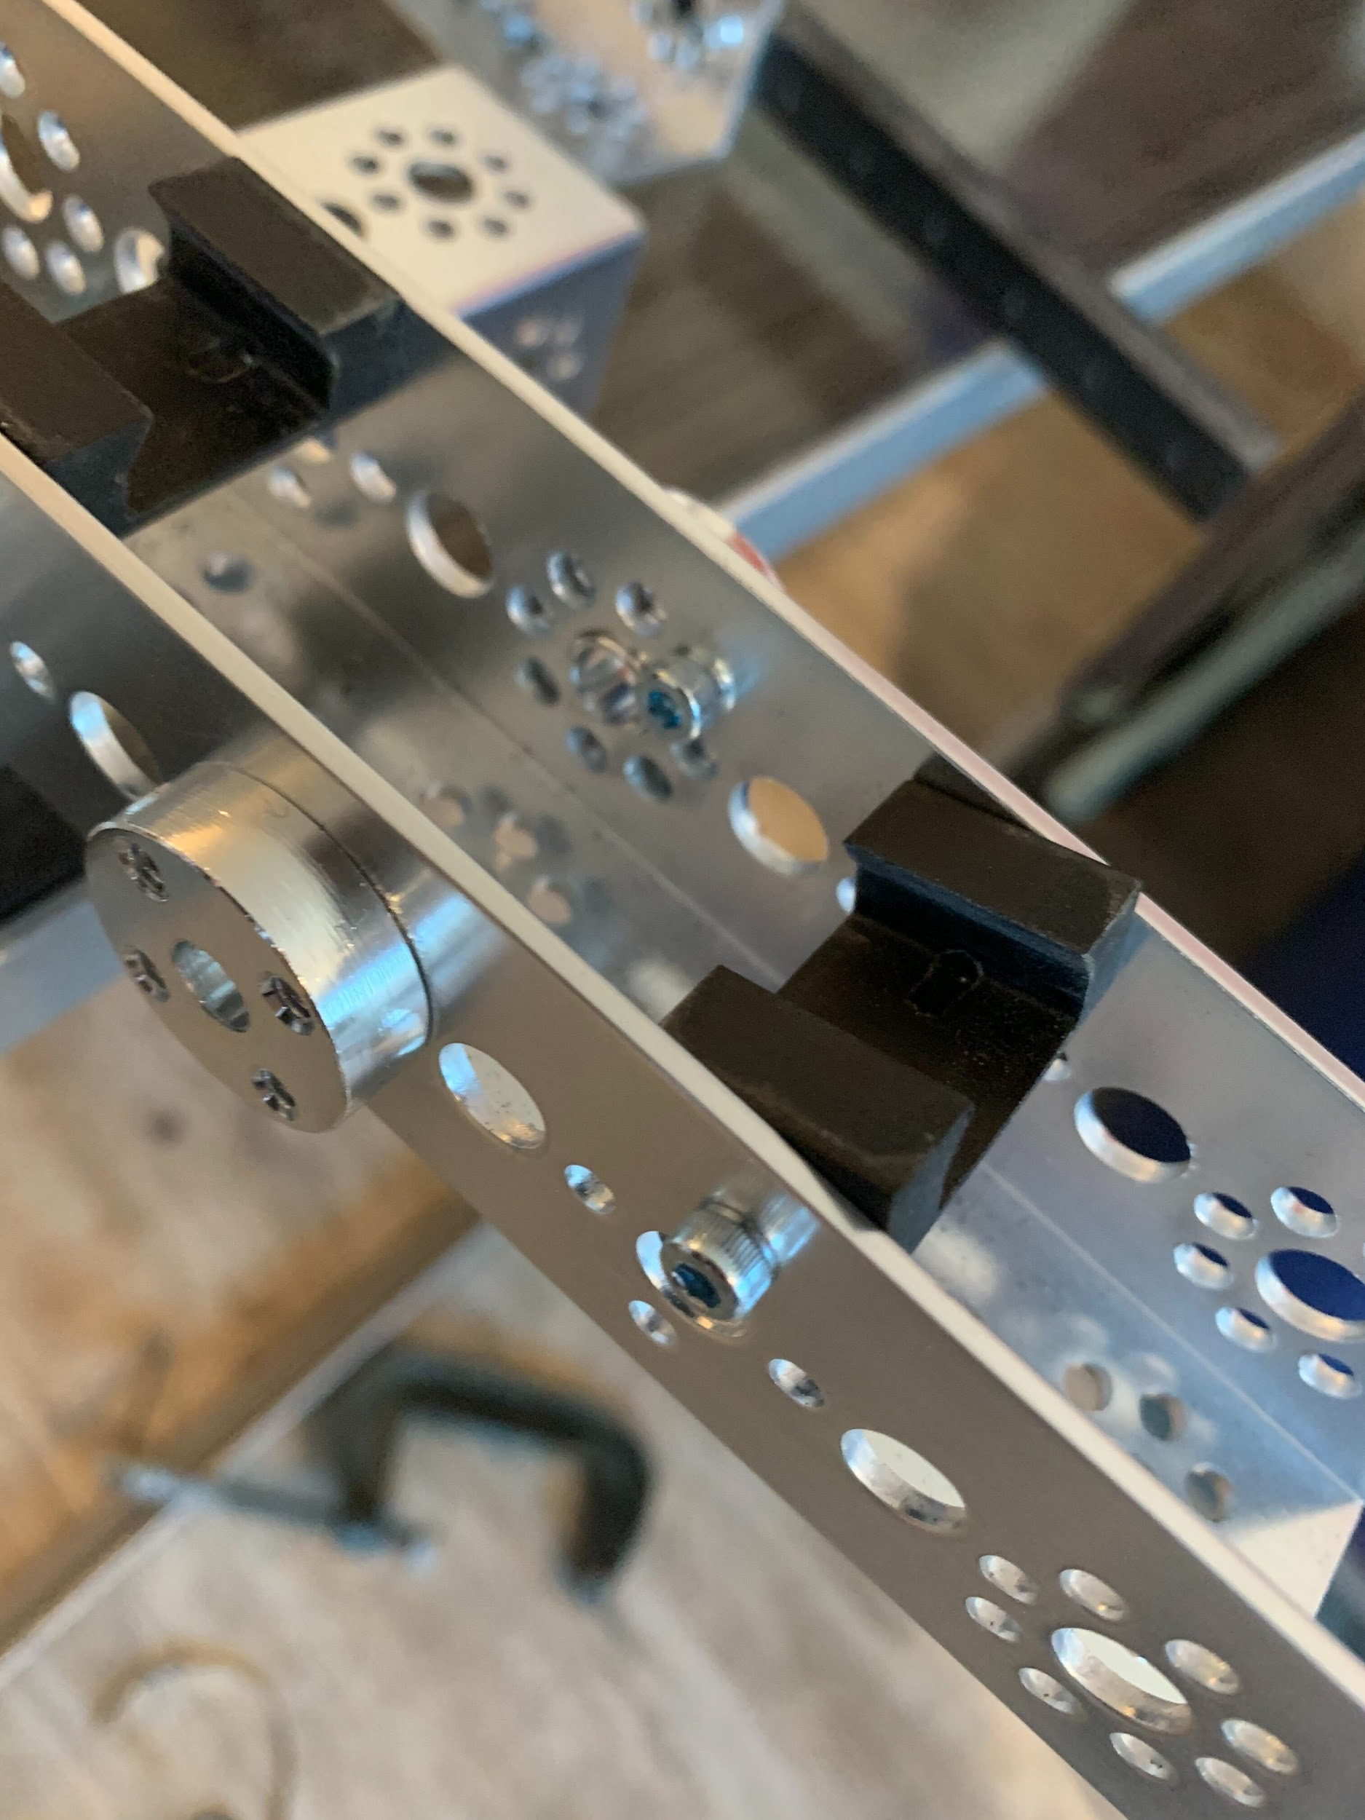

Step 8: Slide fully assembled pipe channel and rack components into sliders inside base plate.